Consortium to Study Trends in Seismicity
Developed by Kansas Geological Survey
Revised 3/8/2017
Introduction
Staggering increases in the rate and size of earthquakes detected across the midcontinent over the last few years have spawned a range of theories and provided fodder for unsubstantiated conjecture as to the source and long-term effects of these unusual levels of seismicity. Abrupt or unexplainable changes in seismicity represent both current and potentially longer-term risk to citizens, property, and infrastructure. It is critical to understand and monitor activities that could influence natural processes in the context of the local geology and tectonics. Activities that affect the natural stress or subsurface rock properties can influence fault stability and alter natural seismicity. Responsible environmental stewardship requires that anthropogenic activities not alter local, natural seismicity beyond thresholds that disturb or adversely impact inhabitants or processes.
Capitalizing on collaborative opportunities to advance our collective understanding of and ability to distinguish natural from induced seismicity provides benefits to industry, government, and the public. Moving the science of seismology (natural and anthropogenic) forward has direct and substantive effects on policies, regulations, and laws that impact industry and ultimately the general public. Formulating partnerships between industry, government, and academic research communities has marked value for the citizens of Kansas. To that end, a research consortium, powered by industry and driven by science and data that focuses on quantifying and evaluating low-level background seismicity and monitoring for changes in seismicity, could help establish viable local guidelines needed for identifying and controlling seismicity change and characterize geologic structures or features with seismic sensitivities.
University-based investigative efforts in partnership with government and industry provide transparency, resources, and broad, science-driven motivations for efficient and nimble advances in understanding seismicity and its drivers at all scales. A university, government, and industry investigative consortium could partner the best expertise, resources, motivation, and convenience with a mission to discover and understand the catalysts for, recursion of, and differences between natural and induced seismic events. This partnership would encourage government cooperation in the development of industrial practices suited to operate under economic drivers while cognizant of environmental safety and full community awareness. This consortium will facilitate meeting those goals in a fashion well beyond anything possible through independent operation and the potentially redundant monitoring activities.
Kansas Network
The Kansas Geological Survey owns and operates a permanent network designed to monitor regional seismic activity and a temporary/portable array focused on investigating, at great detail
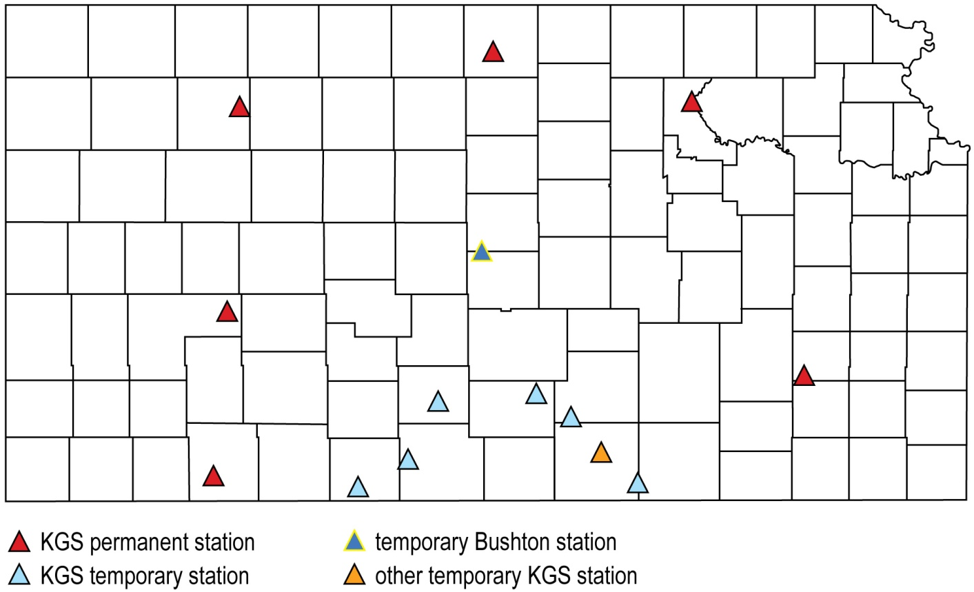
Figure 1. Active stations in the KGS network.
and very high resolution, specific features or zones of elevated earthquake activity (Figure 1). With earthquake recording and analysis experience dating back to the late 1970s, the KGS brings a wide geoscience perspective to the problem. One key advantage held by KGS scientists and administrators is that the KGS has no regulatory responsibilities or institutional directives that divert it from unbiased, science-based discovery.
Study of small-scale seismicity in a patchwork fashion allows cost effective detection and delineation of micro earthquakes originating from faults with township and smaller textures that could possess seismic sensitivity to changes in subsurface conditions. A systematic plan for locating stations will allow the stitching together of a seismicity map that possesses extreme resolution and sensitivity in proximity to Consortium member wells. Once the areal extent of local seismic features are defined, a range of options for sustainable industrial disposal processes (i.e., fluid disposal through deep injection) can be tailored with enhanced spatial awareness of susceptible and critically stressed faults. A partnership that includes a statewide research organization operating without bias, industry interests driven by high standards of environmental stewardship and economic advancement, and government representatives tasked with overseeing and protecting the land and water is clearly in the interests of the citizens of Kansas.
Arguably the most significant challenge to understanding the influence and impact of human activity on faults and earthquakes is establishing background seismicity both at and below felt levels for periods of upwards of a decade. Earthquakes occur when critical stress is applied to properly conditioned faults. Earthquake trends can be altered by changes in physical properties along the fault plane. Also, properly aligned faults in areas where stresses have the potential to exceed clamping, frictional forces can experience failure and produce earthquakes. The amount of energy released depends on the size of the fault rupture and prefailure force per unit area. Not all faults produce earthquakes. In most areas recursion relations are derived from historical earthquake activity.
Earthquake Patterns and Recursions
Most well-known earthquake-prone areas have empirical recursion relationships based on recorded felt events. Well-established historical trends and recursion relationships can accurately guide expectations/predictions of how large and how many earthquakes to expect along an active fault surface. In areas without large faults or high stress fields, but with small faults and minimal stress fields, earthquakes still occur, but well below the felt threshold and generally following the same Gutenberg–Richter recursion relationship applicable to felt earthquakes. These small faults, or small ruptures on larger faults, produce thousands of earthquakes that go unfelt, undetected, and present no risk. These small earthquakes are generally in areas with no means to record their energy arrivals or are so small relative to felt earthquakes they go completely unnoticed or overlooked.
Active earthquake areas or areas with small faults and low slip rates or recursions can undergo changes in the frequency and size of earthquakes if physical properties or pressures along their fault planes are altered. It is, therefore, critical when planning/proposing any anthropogenic activity that might perturb a fault surface or alter any physical property or force distributions along a fault plane to monitor, identify, and quantify earthquakes even at very low seismicity (rates and size of earthquakes) in advance of implementing an activity with inducing potential.
Areas with low levels of seismicity possess the potential for experiencing elevated seismicity with changes in subsurface conditions and should be considered problematic when establishing new or increasing current levels of injection. Avoiding seismically sensitive zones is preferred, but under well-defined constraints and monitoring, sensitive zones could be used safely and economically. Monitoring efforts that have taken place over the last three-plus decades in Kansas have regionally identified the major zones of seismic sensitivity, but more focused and higher resolution monitoring is clearly necessary to capture all the local seismically sensitive zones that exist throughout Kansas and the midcontinent. Broadening the understanding and awareness of seismicity below the regional monitoring level is critical for development or enhancement of commercial activities that involve deep disposal of waste fluids.
The KGS has historically and is currently committing significant resources to defining features and zones where seismicity exists or is elevated, and where it is believed the potential exists for felt magnitude levels. Understanding the potential of seismic features or zones to produce damaging earthquakes within decades to a century time frame is essential to establishing guidelines to protect the environment and general public.
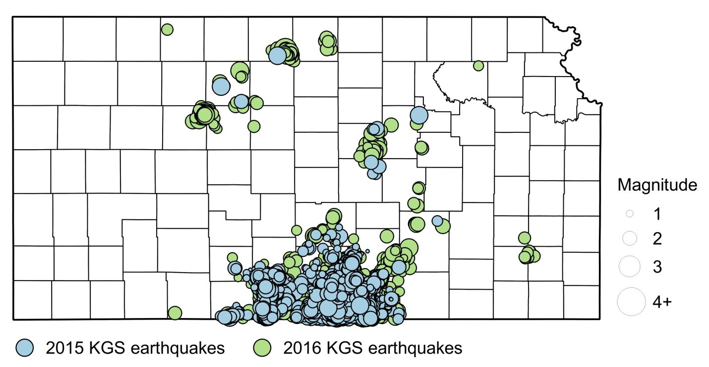
Figure 2. Location and relative size of earthquakes located by the KGS/KCC temporary network during 2015 and 2016 are displayed relative to the county boundaries in Kansas. Almost 8,000 events were located between 0.0M and 4.0M during that year.
Partnering with the Kansas Corporation Commission during 2015, the KGS deployed a six-station temporary earthquake array tuned to record earthquakes generally down to magnitude 1.5 in a nine-county area of southern Kansas (Figure 2). This network has resulted in the detection and high confidence location of more than 8,000 earthquakes. Without this KGS/KCC temporary network, around 90% of those 8,000 events would have gone completely undetected by the USGS and OGS network that has been and continue to operate in this region. The small events that make up this 90% provide real insights into seismically sensitive zones and areas where risk of inducing earthquakes from injected fluids is the highest in this nine-county area.
Data Driven Consortium
It will be a primary goal of this consortium to build a measurement-based understanding of local macro- and microseismicity well below energy levels discriminated and considered locatable with existing regional networks and, therefore, dramatically below felt thresholds. Background seismicity will provide data-driven correlations between historical and current seismicity. Areas exhibiting low, but measurable levels of seismicity represent potential opportunities for redistributing the natural stress balance through new or enhanced commercial injection processes and thereby affect existing earthquake recursion relationships.
Consortium members will be provided statistics, analysis, and associated interpretations of local and regional seismicity on a routine basis to feed think-tank type discussions intended to define high priority areas for enhanced monitoring. The group will benefit from both very preliminary and fully developed observations and findings. The consortium will also provide a strong voice in steering ancillary, focused applied research efforts that move well beyond recording and cataloging seismicity.
This program will be defined, focused, and appraised by both long- and short-term goals. Long-term goals will generally target temporal and spatial trends within 15 miles of Partner injection wells, with enhanced focus on identifying irregularities that are either locally consistent with normal background seismicity for an area or unique to specific geologic features. These long-term goals are intended to dramatically improve confidence in discriminating natural fluctuations from anthropogenic altered seismicity. Short-term goals will have milestones generally defined on sub-yearly to half-decade durations, primarily focusing on county-size areal mapping of low-level seismicity and establishment of meaningful trends and interpretations in proximity to Partner wells. Over the first few years of the program, areas potentially related to current and projected future operations of consortium members will be the focus and priority in establishing goals and defining anticipated accomplishments.
One five-year goal of the program will be to produce a high-density sensor-based regional earthquake database made up of continuous recording from as many as 15 unique station locations. Data from the consortium’s stations in conjunction with KGS permanent stations will provide the necessary surficial coverage to establish a baseline understanding of the current seismicity across the state well below any awareness currently possible. With the KGS permanent stations providing the continuity necessary to correct for temporal variability that will result from the addition of multiple consortium station, the data sets should seamlessly merge to produce a uniform microseismicity map.
Station locations will be chosen to optimally infill the eight-station Kansas permanent network, be within 15 miles of each member well, record earthquakes well below 0M within 15 miles of partner wells, and minimize azimuthal gap around member wells. Each station deployment will be selected based on the consortium’s highest need and result in both a local micro seismicity map and enhance regional seismicity maps.
Eventually each local micro-seismic map produced as part of this objective will contribute to a regional base map incorporated with full state seismicity maps, providing unique opportunities to establish characteristics that distinguish areas of natural and potentially induced micro- to macroseismicity relatable to interpreted or known structures. The consortium should have the resources necessary to make well informed data-driven decisions as to monitoring priorities and objectives throughout Partner areas across the State of Kansas.
Member Value Deliverables
Principal participants for this initial consortium group will be operators of Class 1 disposal wells. Class 1 wells in Kansas operate in 13 counties (Figure 3) and fall under the regulatory oversight of the Kansas Department of Health and Environment. This is, first and foremost, a data acquisition and analysis consortium focused on serving the current and future needs of this community of industrial partners. Research and the advancement of the science will be a natural byproduct of this program, but not the primary mission of the consortium. As with all high quality data sets, data acquired through this consortium will no doubt lead to groundbreaking research providing insights into processes and triggers for inducing seismicity as well as unprecedented opportunities to document and study seismicity at micro-levels on a regional scale.
To establish baseline seismicity down to a M1 or lower energy level, earthquake stations will be located within about 15 miles of each partner well, areas of industry activity, and positioned to optimally record earthquakes within the collective footprint of all nearby stations. Ideally, the azimuthal coverage should be less than 100 degrees. To accomplish this and to begin construction of the seismicity net, stations should be deployed temporarily and locally matched to Partner wells for a period of around 6 months to a year. Priority will be given to areas of greatest seismic concern, industry interest, with the greatest density of partner disposal wells, or some combination of the previous. If the station location proves to allow the recording of high quality data, the station location will be considered fixed, but if the data quality is not sufficient to meet the objectives of the consortium a new location with be selected and the station moved as long as it retains the primary criteria of proximity to the target well(s).
Each quarter a preliminary report will be provided to members of the consortium. The reports will list all pertinent earthquake locations (within 100 km of a member’s resources) and their characteristics, augmented with a supplemental report focusing on the sub-regional area (two to three counties in size) where the current network is deployed and tuned to. Discussions will focus on trends, geologic features of interest, and, to a limited degree, attempt to identify patterns that help to distinguish natural processes and cycles from anthropogenic aberrations.
An immediate notification will be sent to the owner’s representative and predetermined representatives of the State of Kansas in the event an earthquake of magnitude 2.5 (member-determined lower limit) or larger occurs within 15 miles of a Class 1 well. Annually the consortium will hold a board-style meeting where findings and plans will be discussed, primary objectives updated, and the dynamic monitoring plan reaffirmed, continuously updating the priorities and focus necessary for characterizing seismicity patterns in and around the 13-plus counties where Class 1 operators have an interest.
The consortium will develop and annually review goals and objectives of the network and associated analysis, both for the current deployment as well as potential future planned locations and configurations. Key to optimizing information and collecting data of greatest value to consortium members will be the development of a dynamic plan for building a comprehensive seismic
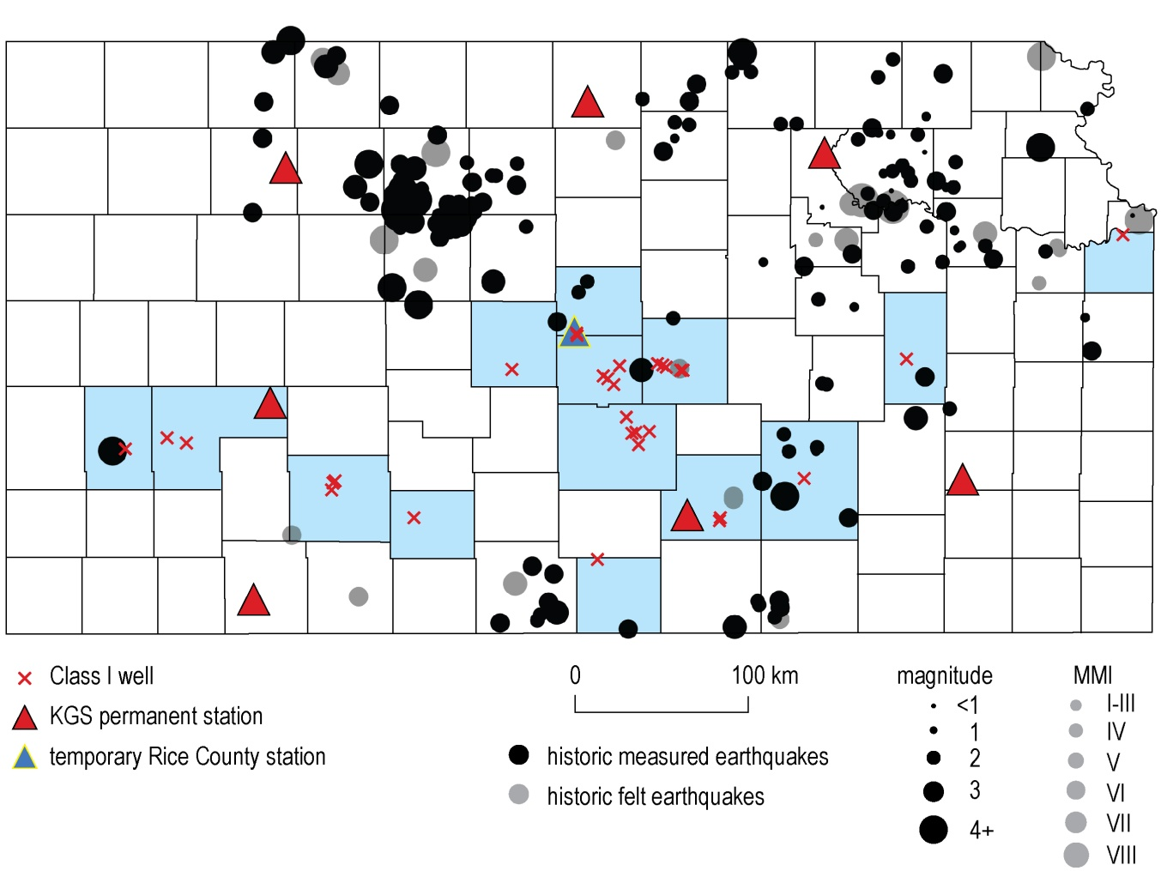
Figure 3. Distribution across Kansas of permanent network stations, as well as a potential first deployment of the three new temporary stations with a possible location for the permanent station funded by this consortium. All
Class 1 wells are also plotted relative to both historical measured and felt earthquakes.
sensitivity map (seismicity net). Such a map will highlight areas currently producing low energy earthquakes and infer the fault(s) or fault zones likely playing a role in measured ground motion. Seismicity zones will be identified and their susceptibility to producing earthquakes established, such that downstream decisions by industry partners related to site-specific future operations will have the benefit of incorporating data-supported and scientifically defensible, low-level seismicity maps. This is contrasted with current approximations and guesses based on extrapolation of regional data points recorded at stations lacking the sensitivity to delineate small magnitude trends.
Areas with low-level natural seismicity already have favorable stresses and structures in place to produce earthquakes; for most susceptible fault structures we have only a cursory understanding of maximum potential yield. It would be prudent for injection schemes to avoid disturbing the natural balance and thereby potentially facilitate an unnatural increase in felt earthquakes. It is critical that areas susceptible or seismically sensitive to changes in pore pressure be identified and sensitive zones delineated using high-fidelity earthquake data, allowing data-driven concerns for localized injection to be established and properly compensated for.
Ultimately the goal of this consortium is to provide information to support plans for optimizing injection patterns (spatial or temporal) or rates/volumes of injected fluid to ensure safe disposal in approved underground aquifers without interfering with accepted and economic industry practices. As well, by establishing background seismicity levels for an area, ground motion changes related to natural processes can be separated from changes due to any anthropogenic activity, thereby providing a science-based support for refuting or confirming an anthropogenic cause.
Budget Justification
Membership in the consortium will be open to all disposal well operators. An initial contribution of $15,000 will be recommended to become a principle participant. Contributions to the consortium efforts will go toward the purchase, installation, supplies, and operation of stations. Designing the distribution/coverage of this network and recording duration at each location will depend on the geographic interests of the principal participants and analysis of local seismicity. Preliminary reporting and analysis discussions will involve and engage the principal participants. General members (members without contributions toward the network—Tier 2) will be provided access to reports and data after principal participants have reviewed, commented on, and approved all data and documents but prior to annual meetings.
Based on current expressed interests by members of the Class 1 operators community we anticipate initially to operate 9 stations focused on seismicity within 15 miles of member wells. Effectively recording and analyzing six months of data from these stations will be the focus of and basis for the principal products of the consortium during its initial year of operation (Figure 3). It is anticipated to take about four months to purchase and deploy the 9 stations. The stations will consist of a surface three-component seismometer.
During Year 1 the KGS will use all funds available to purchase equipment and supplies to optimize the coverage of stations with installation and operation occurring as funds become available. A spare station should also be purchased and available to insure as near 100% operation as possible is maintained throughout the year. As a backup during the start-up year(s) the KGS may need to borrow from the existing equipment inventory for back-up and spare parts to meet the underfunded portion of this program.
As the number of principal participants increases over the first year or two, a full station’s worth of equipment will be purchased as each member signs on with every effort made to get stations installed and partially operation during the year the new partner signs up. It is possible, if the response by the Class 1 community is overwhelming and we get upwards of ten to a dozen members, Year 1 budget activities could be completed in optimal fashion (large orders and reduced cost for volume).
At the end of Year 1, the consortium staff will present an earthquake catalog with key earthquake properties and characteristics and a comprehensive report to each principal participant (Tier 1) at least two weeks in advance of the annual meeting for review and approval to provide to Tier 2 members at the annual meeting. As part of the annual meeting, presentations and in-depth discussions will provide principal participants with opportunities to dig deeper into both observations and interpretations of the findings from the localized temporary network as well as the statewide regional network. The detail and accuracy of the earthquake information available to the consortium participants will be unprecedented for this area, with analysis well suited for a wide range of sponsor applications. Network design and focus will be dynamic and change to conform with the interests of the principal participants (Tier 1).
Companies wishing to join the consortium as Tier 1 members will be requested to contribute $17,000 toward purchase and installation of a seismograph station within 15 miles of their well(s).
Annually a $4,000 membership fee will be requested from the principal participants (Tier 1) to operate the network, provide basic analysis, produce the quarterly reports, and facilitate an annual meeting of consortium members. A secure webpage will be maintained to keep members current on earthquake activity and news from the consortium staff. It is anticipated that phone apps and web-based apps will be available and customized for individual interests and needs during out-years. This is principally a data acquisition and analysis consortium, with unprecedented opportunities for curiosity-driven research sanctioned by the consortium. Funds will go directly to tangible products of potential economic impact to the members.
A meeting of the consortium will be held annually to provide oral presentations of findings and to interact with scientists and staff operating the network and analyzing the data. Equally as important, the meeting will provide opportunities to discuss goals and objectives and update annual program milestones as necessary. It will be the intent of the consortium directors to invite KDHE staff to attend the annual meeting and interact with the members. Reports provided to KDHE at that annual meeting will be stamped draft and allow KDHE to hold that material in confidence for 6 months. KDHE can take no action based on or release the reports during that 6 month time window.

Consortium to Study Trends in Seismicity

General Draft Minimum Budget

Initial Station Set-up
Seismometer and sensor cable $ 5,000
Digitizer 6,000
Cell modem, antenna, cable 1,000
Solar panel, mounting bracket, batteries, charge controller, wiring 1,500
GPS antenna and cable 500
Enclosure, conduit, concrete, pole, gravel 1,000
Installation 2,000
Total Single Station Cost $17,000

Operation per station/well
2 visits during 12 month operation $ 1,000
1 Year unlimited cell data 500
Analysis 2,500
Total Annual Operation Cost $ 4,000

Expectation and Limitations of Members
NOTE: THIS SECTION COULD CHANGE BASED ON FINAL AGREEMENT NEGOITATIONS UNDERWAY BETWEEN KUIC AND PARTICIPATING COMPANIES.
Tier 1

Deliverables. KUCR shall use Participation Fees from all organizations participating in Tier 1 of CSTS, including Company (each a “Tier 1 Member,” with organizations in Tier 2 of CSTS referred to herein as “Tier 2 Members”, and all members of the two tiers collectively referred to as “Members”), to:

conduct Monitoring, including but not limited to purchasing, deploying, maintaining, and operating seismograph station equipment, to which KUCR will retain all rights, title, and interest;

maintain a catalog of seismic events recorded via Monitoring, which will be updated weekly, and provide status reports to any Tier 1 members within thirty (30) miles of an earthquake with a magnitude of two (2) or greater within twenty-four (24) hours of such earthquake;

provide summary reports of Monitoring findings on a quarterly basis to Tier 1 Members, which shall include basic analysis of any earthquakes, such as preliminary location, magnitude, and error estimates; and may include discussion of larger trends, patterns, or characteristics of seismic activity (“Quarterly Reports”); and

together with Participation Fees from Tier 2 Members, host an annual meeting of Members, KGS collaborators, and Kansas Department of Health & Environment staff tasked with responsibilities for Class 1 well owners (“KDHE”), during which the annual summary report (“Annual Report”) will be shared, findings discussed, and strategic goals for the following year will be determined (“Annual Meeting”). Each Tier 1 Member has one (1) vote for each item submitted for a vote at the Annual Meeting. Tier 2 Members and KDHE may participate in discussions but have no voting rights. Tier 1 Members shall receive a copy of the Annual Report at least fourteen (14) days in advance of the Annual Meeting for review and comment. Only Tier 1 members can use the findings and analysis presented in the annual or quarterly reports in documents that circulate outside their company.

Tier 2

Deliverables. KUCR shall use Participation Fees from all organizations participating in Tier 2 of CSTS, including Company (each a “Tier 2 Member,” with organizations in Tier 1 of CSTS referred to herein as “Tier 1 Members”, and all members of the two tiers collectively referred to as “Members”), to:

conduct Monitoring, that could include but not limited to operating a roving, temporary network of seismography stations; to which KUCR will retain all rights, title, and interest; across the state of Kansas to provide general awareness of seismicity in areas of interest to the CSTS; and

together with Participation Fees from Tier 1 Members, host an annual meeting of Members, KGS collaborators, and Kansas Department of Health & Environment staff tasked with responsibilities for Class 1 well owners (“KDHE”), during which the annual summary report (“Annual Report”) will be shared, findings discussed, and strategic goals for the following year determined (“Annual Meeting”). Each Tier 1 Member has one (1) vote for each item submitted for a vote at the Annual Meeting. Tier 2 Members and KDHE may participate in discussions but have no voting rights. Annual reports provided to Tier 2 members can be used for internal company use only and not incorporated into documents distributed outside the company.

